Proposed AC – DC block diagram.
For an ultra-high conversion efficiency (over 95%) and compact AC-DC power conversion board, we've thought about the following key aspects:

Functional Block:
- Input AC Voltage → EMI Filter → PFC Stage → Bridge Rectifier → LLC Resonant Converter.
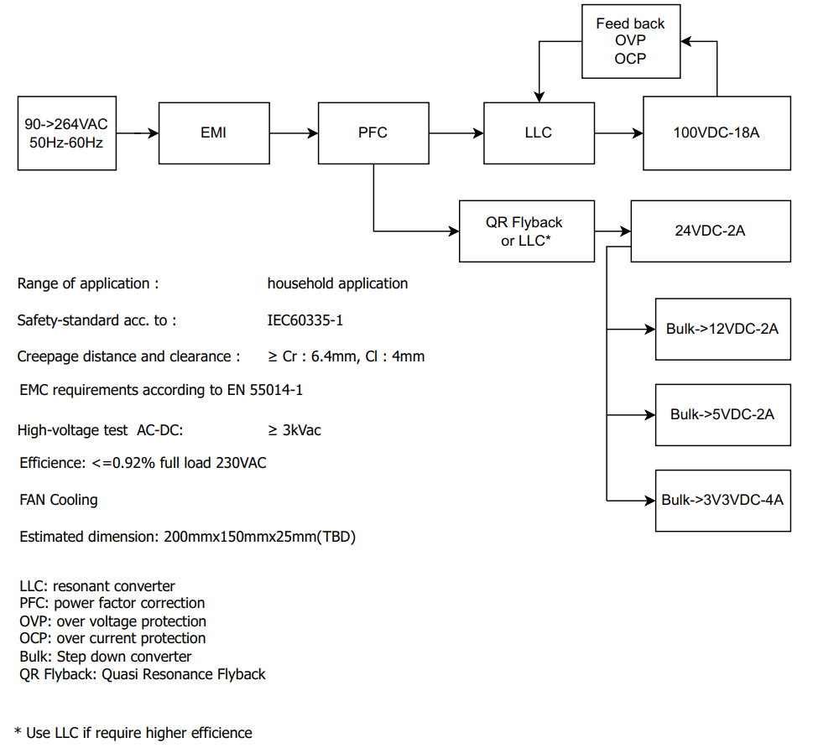

System Architecture and Topology: Choosing the right topology is crucial for achieving high efficiency and compact size. For this application, a resonant converter topology, such as the LLC resonant converter, is ideal due to its high efficiency, soft-switching capabilities, and compact design. Additionally, for the DC-DC conversion stages, we will employ synchronous buck converters, known for their efficiency and compact size.
EMC/EMI Considerations: The design will include EMI filters and shielding to meet EMC standards for consumer electronics. A piezoelectric EMI filter will be considered to reduce conducted emissions.
Power Management and Control: A Power Management IC (PMIC) will be used for monitoring and controlling the output voltages and currents. This IC will include protection features such as over-voltage, over-current, and thermal shutdown.
Critical Components and Modules: Selection of components such as GaN-based transistors for high efficiency and compact size, transformers for isolation, and low-profile capacitors and inductors.

Block Diagram High-Level Overview

This is a draft overview of the components and their connections, ensuring a compact and efficient design suitable for consumer electronics applications. The choice of GaN transistors, resonant converter topology, and synchronous buck converters ensures high efficiency and compactness. The inclusion of EMC/EMI filtering and protection features ensures safety and compliance with regulatory standards.

We expect that the supplier does through review... recommend any changes (if any) or recommend their system.
- Input Stage:
  - EMI Filter: Includes common-mode chokes and capacitors for noise suppression.
  - Bridge Rectifier: Converts AC to DC.
- Primary Stage (High Voltage Side):
  - LLC Resonant Converter: Provides efficient DC-DC conversion with galvanic isolation. Key components include resonant capacitors, a transformer, and synchronous rectifiers.
- Secondary Stage (Low Voltage Side):
  - Synchronous Buck Converters: For generating 3.3V, 5V, 12V, and 24V outputs. Each stage will have its own control circuitry for regulation.
- Control and Monitoring:
  - PMIC: Manages power conversion, monitors output voltages and currents, and provides protection features.
  - Current and Voltage Sensors: For monitoring and feedback.

Component and Functional Details
- Input Stage:
  - EMI Filter:
    - L1, C1, C2: Common-mode choke (L1 – Inductor Symbol) and Y-capacitors (C1,C2) for differential and common-mode noise suppression.
    - F1: Input fuse for overcurrent protection.
    - Components: Common-mode choke (L1), Y-capacitors (C1, C2), input fuse (F1). Review: TDK ACM7060-701-2P-TL00 , R46KI310050M1K, TDK B32922C3104M, Schurter 0001.2511
    - Connections:
      - AC input (90-260VAC, 50-60Hz) enters the EMI filter.
      - After the filter, the signal passes through the inrush current limiter (NTC thermistor).
  - Bridge Rectifier:
    - D1-D4: 4 Diodes arranged in bridge configuration for AC to DC conversion.
    - Components: Diodes (D1-D4). Review: STMicroelectronics STTH30R06CW,
    - Connections:
      - Output of the EMI filter feeds into the bridge rectifier.
      - The rectifier output is a DC voltage.
  - Inrush Current Limiter:
    - NTC Thermistor: To limit the inrush current.
- Primary Stage (High Voltage Side):
  - LLC Resonant Converter:
    - Q1, Q2: GaN FETs for high-efficiency switching (high-efficiency GaN transistors.)
    - Lr, Cr: Resonant inductor and capacitor in series.
    - T1: High-frequency transformer for isolation and voltage step-down.
    - Components: GaN FETs (Q1, Q2), resonant inductor (Lr), resonant capacitor (Cr), transformer (T1).
      - Review: EPC EPC2045, Infineon IGOT60R070D1, Texas Instruments LMG3410R070
      - Review: Coilcraft LPR6235 Series, SRR1260-100M
      - Review: b32674d3126k000
    - Connections:
      - Rectified DC input is fed into the LLC resonant converter.
      - The transformer provides galvanic isolation and voltage conversion.
  - Synchronous Rectification:
    - Q3, Q4: Synchronous rectifiers for efficient DC output.
    - Components: Synchronous rectifiers (Q3, Q4).
    - Connections:
      - The output of the transformer is rectified using synchronous rectifiers.
- Secondary Stage (Low Voltage Side):
  - Output Filters:
    - L2-L5, C3-C6: LC filter - Inductors and capacitors for smoothing the output voltages.
  - Synchronous Buck Converters:
    - For 3.3V, 5V, 12V, 24V outputs:
      - Q5-Q8: Synchronous rectifiers – transistors for each output stage.
      - L6-L9, C7-C10: Output filter components.
    - Components: Synchronous rectifiers (Q5-Q8), output inductors (L6-L9), output capacitors (C7-C10).
    - Outputs:
      - 3.3V, 4A: Synchronous buck converter 1.
      - 5V, 2A: Synchronous buck converter 2.
      - 12V, 2A: Synchronous buck converter 3.
      - 24V, 2A: Synchronous buck converter 4.
- Control and Monitoring:
  - PMIC: Integrated circuits for power management.
    - Functions: Voltage regulation, current monitoring, protection.
    - Connections:
      - Connected to all outputs for monitoring and regulation.
  - Sensors: For voltage and current feedback.
    - Components: Voltage and current sensors.
    - Connections:
      - Provide feedback to PMIC.
- Auxiliary Components:
  - Thermal Management: Heatsinks and thermal pads (GaN FETs, Synchronous Rectifiers, LLC, IC, Inductor)
  - Protection: TVS diodes, Zener diodes, (parallel with output lines for overvoltage protection.) and fuses for overcurrent protection.
    - Components: TVS diodes, Zener diodes, additional fuses.
    - Connections:
      - Placed across outputs and critical paths for protection.

Annotations and Descriptions
- Input: 90-260VAC, 50-60Hz.
- High Voltage DC Output: 100VDC, 16-18A, 1.5kW.
- Low Voltage Outputs:
  - 3.3V, 4A.
  - 5V, 2A.
  - 12V, 2A.
  - 24V, 2A.
- Control Signals: PWM signals for controlling the converters, feedback signals for voltage and current monitoring.
Diagram Layout
- Left Side (Input Stage): EMI filter, bridge rectifier, and inrush current limiter.
- Center (Primary Stage): LLC resonant converter, transformer, and synchronous rectifiers.
- Right Side (Secondary Stage): Synchronous buck converters, each labeled with output voltages.
- Bottom (Control and Monitoring): PMIC, sensors.
- Top (Auxiliary): Thermal management and protection features.

